Smart Home Electronic Security System
Godfrey Ouma
University of the People
CS 1105-01: Digital Electronics & Computer Architecture
Afrah Nazir
July 4, 2024

Smart Home Electronic Security System
Scenario:
Imagine you are working as an intern at a tech company specializing in electronic devices. As part of your training, you have been given the task of designing a simple electronic security system for a smart home using combinational circuits. The security system should be able to control access to different rooms in the house and allow authorized users to enter using a code or key card.
Assignment:
- Compose a design for the electronic security system using logic gates, multiplexers, decoders, and encoders.
The electronic security system for the smart home will be designed using logic gates, multiplexers, decoders, and encoders to control access to different rooms in the house.
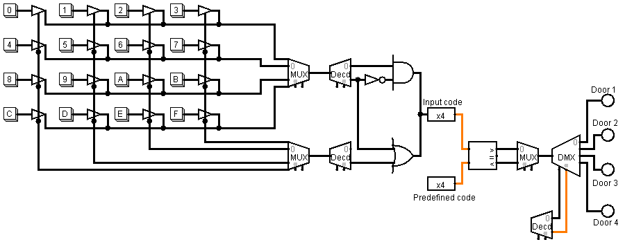
- Explain how each component will be incorporated and how they will work together to achieve the desired functionality.
The system will incorporate a 4x4 matrix keypad for input of the door code, and the following components will be integrated to achieve the desired functionality:
- 4x4 Matrix Keypad: This will provide the input for the door code, allowing authorized users to enter the rooms.
- Multiplexers (MUX): Two multiplexers will be used to read the rows and columns separately from the matrix keypad, enabling the system to process the input effectively.
- Decoder: The decoder will scan the inputs of the key pressed from the row and column, converting the input signals into a form that can be used by the system.
- Encoder: The encoder will convert the scanned input into a 4-bit binary code, which can then be processed further.
- Comparator: The comparator will compare the input code with a predefined code as part of the validation process to determine whether access should be granted.
- Logic Gates: The logic gates will be used to implement the logic for access control decisions based on the output of the comparator.
- Multiplexer (MUX): Another multiplexer will be used to select the input from the comparator to determine which room's access control to activate, allowing the system to control access to multiple rooms.
- Decoder: A decoder will decode the selected input to control the door locks of the respective rooms, enabling access to be granted or denied based on the input code.
The functionality of the design involves the keypad input being processed by the multiplexers, decoded, and then encoded into a 4-bit binary code. This code is compared by the comparator to the predefined code for validation. If the input matches the predefined code, the multiplexer selects the input to determine which room's access control to activate. The selected input is then decoded to control the door locks of the respective rooms using logic gates for access control decisions.
- Enhance your design by summarizing how you could integrate a demultiplexer into the system to handle multiple rooms' access control efficiently.
To efficiently handle multiple rooms' access control, a demultiplexer (DEMUX) can be integrated into the system. The DEMUX will take a single input signal from the comparator and route it to one of several output lines, each corresponding to a different room. This allows the system to control access to multiple rooms using a single comparator and encoder.

References
Ndjountche, T. (2016). Digital electronics 1: Combinational logic circuits. John Wiley & Sons, Incorporated.
Tocci, R., Widmer, N., & Moss, G. (2017). Digital systems (12th ed.). Pearson.

